Warning – Hill Start Assist – C490 MEA Specific – CGEA1.3

Functional Description

This STSS is specific to C490 MEA because this cluster is out of space for LED based telltales and thus they cannot support “Hill Start Assist Telltale - CGEA 1.3”. Instead, they have to implement the telltale as a warning. This STSS should NOT be used on any other program without DI Core approval.

The Hill Start Assist (HSA) feature assists the driver in hill-starting the vehicle uphill. The driver is able to drive off on a slope easily (without rolling downhill) and comfortably (without lurching uphill) without the need to apply the park-brake. The warning message for HSA failure is “Hill Start Assist Not Available”.

Note that since there is no telltale in this application, the warning is active when the input message is missing.

Interfaces

Interface Context Diagram (I/O Block Diagram)
Figure 1 Warning – Hill Start Assist Context Diagram

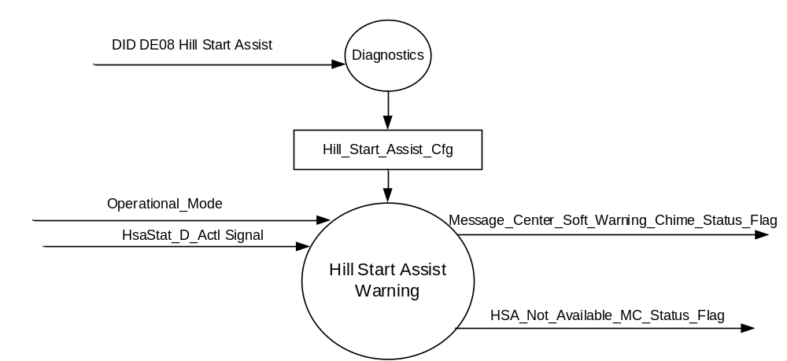

Inputs
      - INTERNAL:
    - Operational_Mode
    - Hill_Start_Assist_Cfg

      - MUX message on the CAN Bus from ABS

- HsaStat_D_Actl Signal
Signal Name | Size (bits) | Detail | Units | Res. | Offset | State Encoded | Min | Max
HsaStat_D_Actl | 3 |  | SED | 1 | 0 |  | 0x0 | 7 (0x7)
 |  | Inactive |  |  |  | 0x0
 |  | FindingGradient |  |  |  | 0x1
 |  | ActiveBrakePedalPressed |  |  |  | 0x2
 |  | ActiveBrakePedalReleased |  |  |  | 0x3
 |  | FastRelease |  |  |  | 0x4
 |  | SlowRelease |  |  |  | 0x5
 |  | Failed |  |  |  | 0x6
 |  | Undefined |  |  |  | 0x7

Output
- HSA_Not_Available_MC_Status_Flag, which is used to control the state of the Hill Start Assist Not Available message.
- Message_Center_Soft_Warning_Chime_Status_Flag

Function/Performance

Operational Modes

Mode | Differentiating Vehicle Conditions
Sleep Mode | Inactive
Limited Mode | Inactive
Normal Mode | HSA Text Message Warnings Inactive/Active
Crank Mode | HSA Text Message Warnings Inactive/Active

The above table references the setting of the Warning flag as per this section. However, the actual warning display operational modes are displayed in the Message Center section of this SPSS.

Voltage Levels

Refer to the Cluster Features Table located in the Operational Modes and Voltage Range Strategies Section of this SPSS.

Human-Machine Interface

Visual

Indicator Graphics / Display Format
Message Center Text Warning Messages as defined in section 1.3.5.7 of this document.

1.3.3.1.2 Indicator Color Coordinates

Reference section COLOR & ILLUMINATION REQUIREMENTS (GRAPHICS).

Audio

The Message Center Soft Warning Chime is associated with this Warning.
Message_Center_Soft_Warning_Chime_Status_Flag

Switch Control Logic

None.

System Accuracy

Within 100 msec of receiving a message that results in a change of state the cluster will update the output flag to the proper state.

Operation: Performance and Functional

Subsystem Algorithm Flowchart / State Diagram

Figure 2: HSA Diagnostic Configuration Flowchart
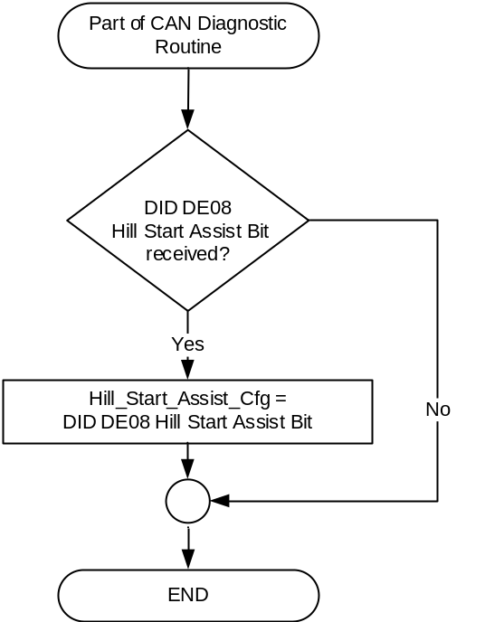

- State Matrix for Hill Start Assist Not Available Warning
Operational_Mode | HsaStat_D_Actl Signal | HSA_Not_Available_  MC_Status_Flag
Normal or Crank | Failed (0x6) | Active
Normal or Crank | Missing as per 1.4.1 | Active
All Other Cases |  | Inactive

- Hill Start Assist Not Available MC Status Flag to MC Warning Message ID

HSA_Not_Available_MC_Status_Flag | MC Warning Message ID | Active Chime_Status_Flag
Active | W1429 (Hill Start Assist Not Available) | Message_Center_Soft_Warning_  Chime_Status_Flag

Operation Description (supports algorithm flowchart /state diagram)

- For definition of how the Message Center arbitrates and displays Active warnings, see the Warning / Alert Display Logic Diagram, located in the Message Center – X Display with W Button Interface section of this SPSS (where X and W are appropriate values in this document).

Function Safety Classification (EMC)

Class B

Memory Storage
Parameter Name | Description | Value at  Battery Connect | Value at  Module Wake-up
Hill_Start_Assist_Cfg | Defined in DID DE08. 0 = Disabled, 1 = Enabled | Use Stored Value | Use Stored Value
HsaStat_D_Actl Signal | Input CAN signal sent from the ABS. | Inactive (0x0) | Inactive (0x0)
HSA_Not_Available_MC_Status_Flag | State variable used by M/C Warning Arbitrator | INACTIVE | INACTIVE
Operational_Mode | 4 state indicator for cluster operational mode | Limited | Limited, Normal or Crank
Message_Center_Soft_Warning_  Chime_Status_Flag | Used to control the state of the chime to the Chime Arbitrator | Inactive | Inactive

Prove Out

No.

Reconfigurable Telltale

No.

Message Center Msg

Refer to Message Center Function description reference "Global Text Message List" file -- Message ID W1429.

Error Handling

Missing Message Strategy

The signals will be declared missing as per the Diagnostics section of this SPSS.

DTCs states and history will be determined as per the Diagnostics section of this SPSS.

If Hill_Start_Assist_Cfg is Disabled (0x0), the cluster shall never log a DTC due to this feature.

Diagnostics

Self Test

None

Engineering Test Mode

Not Applicable

Part II Performance

Supported Diagnostic Trouble Codes (DTCs)

DTC | Description
C12100 | Lost Communication With Anti-Lock Brake System (ABS) Control Module
C41500 | Invalid Data Received From Anti-Lock Brake System (ABS) Control Module
* If the missing signal has a related update bit, _UB, signal, then the “Invalid Data” DTC is to be logged. Otherwise, the “Lost Communication” DTC is logged.

DID DExx
Block  Num | Block Description | Size (bits) | Type | Byte(s) | Bits | State: Description | "0" | "1" | Default | Comments/  Information
PACKETED BLOCKS
$08 | Option Content (B&A) |  |  | * | * | Hill Start Assist | Disabled | Enabled | 1 = Enabled | Enable if Hill Start Assist feature present in vehicle.
*Byte and bit location to be identified in Part II Specification for this cluster

Reference Specification

Revision History
SPSS Module Revision History

Revision Level | Name | Change Description | Date
1.0 | S. Watkins | Initial release for C490 MEA only. Requestor Nao Qiu, nqiu2@ford.com,83062669.  DI CC date: 8/3/2017 | 8/25/2017

